 | Weekly Task Report  Geo Learn  11/20/19    Mentor: Fabio Santos  Sponser: Dr. Chris Doughty  Team members: Samuel Prasse (lead), Kaitlyn Grubb,  Tyler Pehringer, Joshus Tenakhongva | #9

Weekly Team Task Report #9

Team: GeoLearn |  |  |  |  |  | Date: 11/18/19
Project Title: Improving elementary education with custom online enironmental science lectures

 | Samuel Prassse  Present  On-time |  | Kaitlyn Grubb  Present  On-time | 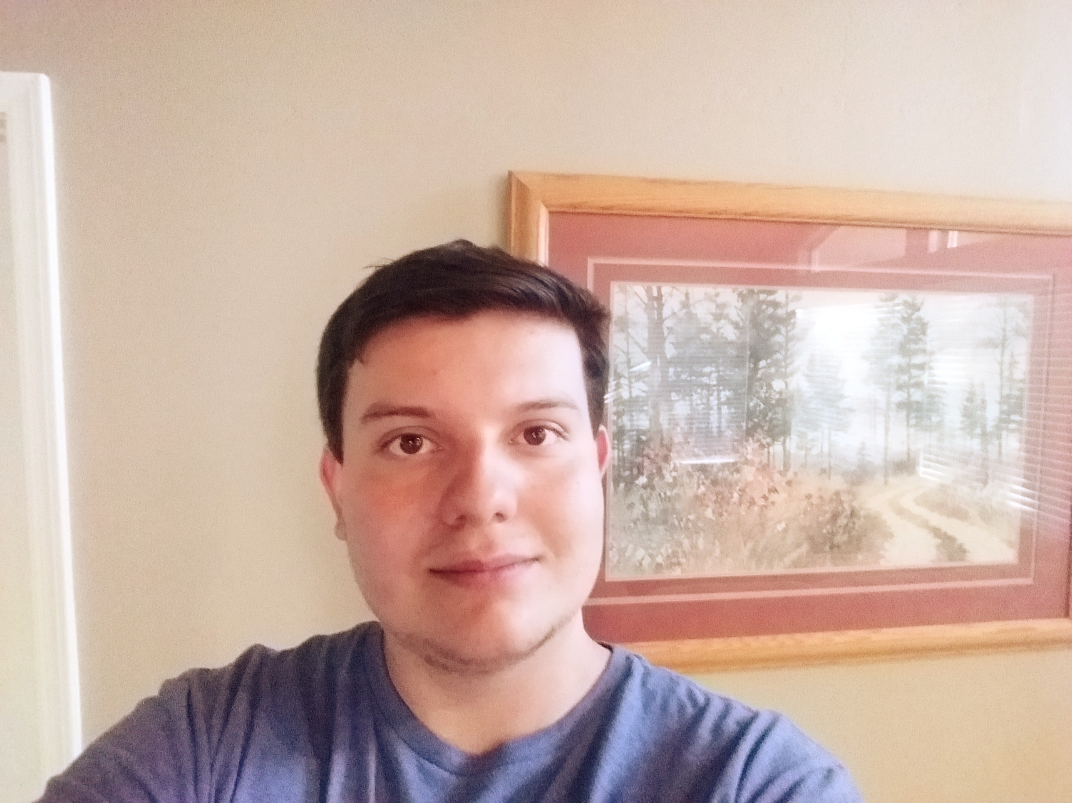 | Tyler Pehringer  Present  On-time |  | 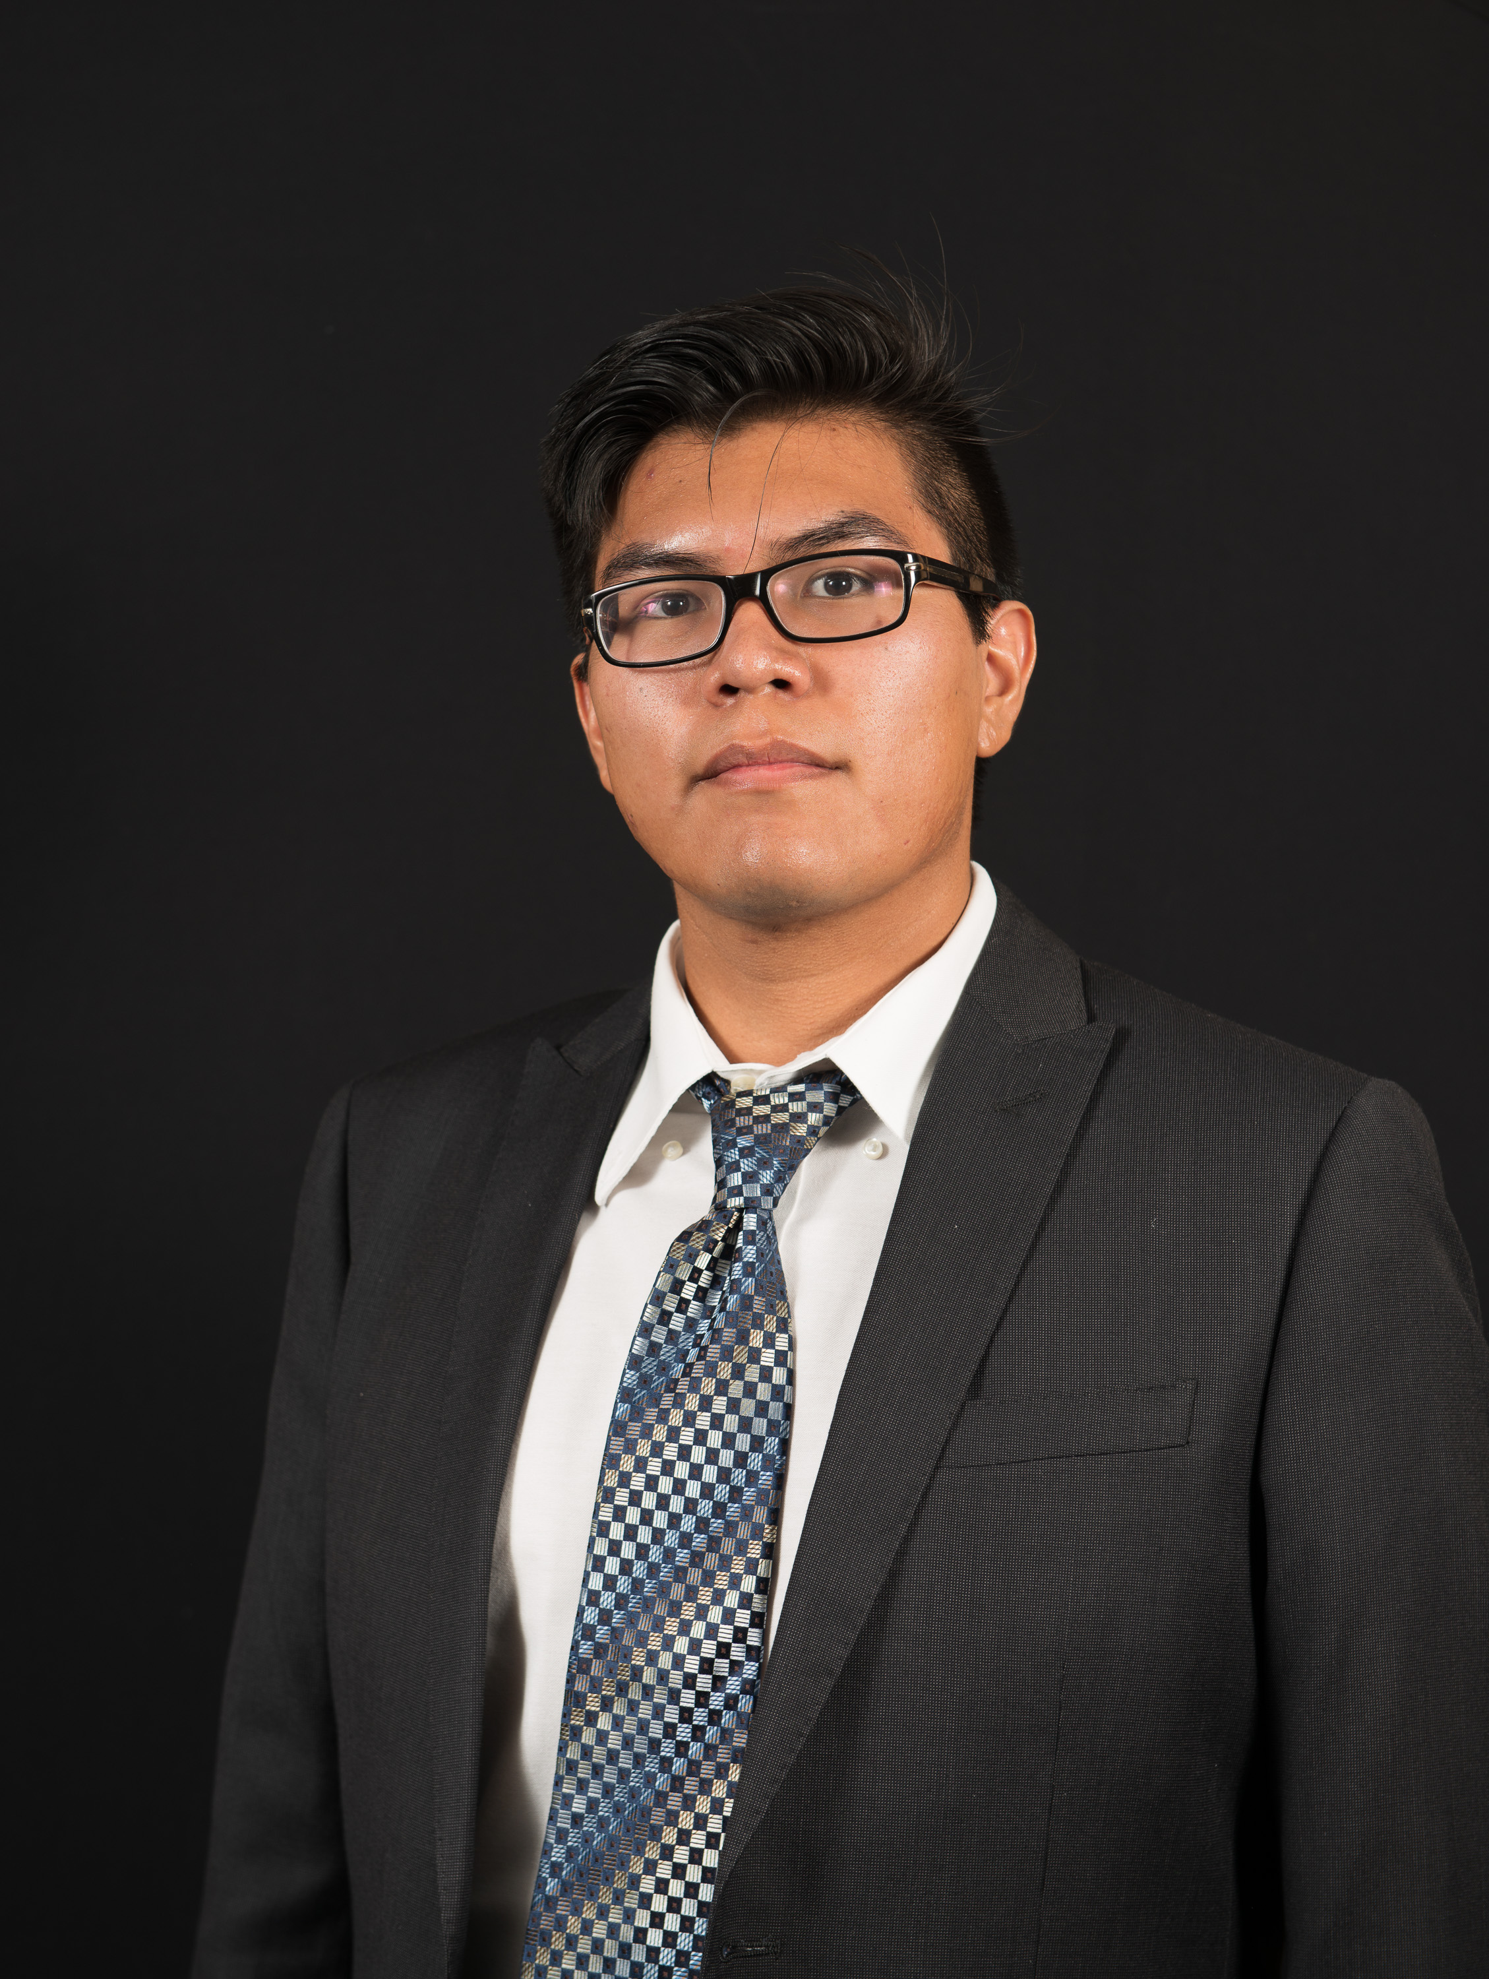 | Joshus Tenakhongva  Present  On-time

Recent Meetings:
- General Team Meeting
- Sponsor Meeting

TASKS COMPLETED since last meeting:
Task Title: Requirements Spec. Dry Run | Task Initiation: 11/11 | Orig. Due Date: 11/13 | Status: Completed
Who (%): Team (100%)
Description: The team will run through our Requirements Specification document with our mentor Fabio. This will take place on November 13th at 2pm in Cline Library. We have split up the document goals into several sections: Intro/Conclusion (Samuel), Schedule (Joshus), Problem Statement (Tyler), Solution Overview (Kaitlyn), and the team will split up the “Key Requirements” section.
Expected Outcome: Receive a review of our slideshow and edits from our mentor to ensure our document contains all the relevant information to get the best grade possible.

This week’s Tasks: Work plan for coming week
Task Title: Requirements Specification | Task Initiation: 10/30 | Orig. Due Date: 11/29 | Status: In Progress
Who (%): Joshus (25%), Kaitlyn (25%), Tyler (25%), Samuel (25%)
Description: The requirements specification is a description of our project’s requiremtnts, both functional and non-functional, and forms the contractural basis for the expectations to be fulfilled by the development team.
Expected Outcome: Create a document outlining the requirements that the team will stick to when developing our project.

Task Title: Design Review 1 / Presentation | Task Initiation: 11/11 | Orig. Due Date: 11/29 / 11/22 | Status: In Progress
Who (%): Joshus (25%), Kaitlyn (25%), Tyler (25%), Samuel (25%)
Description: This document and presentation will consist of an introduction, discussion of the problem statement, our overview of our solution to the problem, key requirements, risks and feasibility, a schedule for the remainder of the semester, and a conclusion. The presentation will be done in class on the 22nd of November.
Expected Outcome: Create a document outlining the requirements that the team will stick to when developing our project. / Present to a mentor and classmates that are not as familiar with our project, and tell them what our longterm plan is.

Task Title: Peer Eval #3 | Task Initiation: 11/18 | Orig. Due Date: 11/29 | Status: In Progress
Who (%): Team (100%)
Description: An accurate representation of effort and time invested by individual team members as graded by the other 3 team members.
Expected Outcome: Send an excel document to our team mentor with a correct peer evaluation of all team members.

Upcoming Tasks: Planning
Task Title: Tech Demo | Who (%): Team (100%) | Rough Due Date: 11/29
Description: We will schedule a time and place to perform a tech demo for our client.

Task Title: Lecture – Config Management | Who (%): Team (100%) | Rough Due Date: 11/29
Description: The team will participate and sit in on the lecture on Configuration Management.

Other Problems / Other Issues:
- Any other things we need to add or remove from our presentation?

